## **What is a Spanning Tree?**

A Spanning tree is a subset to a connected graph G, where all the edges are connected, i.e, one can traverse to any edge from a particular edge with or without intermediates. Also, a spanning tree must not have any cycle in it. Thus we can say that if there are **N**vertices in a connected graph then the no. of edges that a spanning tree may have is **N-1***.*

## **What is a Minimum Spanning Tree?**

Given a connected and undirected graph, a spanning tree of that graph is a subgraph that is a tree and connects all the vertices together. A single graph can have many different spanning trees. A minimum spanning tree(MST) or minimum weight spanning tree for a weighted, connected, undirected graph is a spanning tree with a weight less than or equal to the weight of every other spanning tree. The weight of a spanning tree is the sum of weights given to each edge of the spanning tree.

## **How many edges does a minimum spanning tree has?**

A minimum spanning tree has (V – 1) edges where **V** is the number of vertices in the given graph.

## **How to find MST using Kruskal’s algorithm?**

Below are the steps for finding MST using Kruskal’s algorithm:

1. Sort all the edges in non-decreasing order of their weight.
2. Pick the smallest edge. Check if it forms a cycle with the spanning tree formed so far. If the cycle is not formed, include this edge. Else, discard it.
3. Repeat step#2 until there are (V-1) edges in the spanning tree.

*Step #2 uses the* [*Union-Find algorithm*](https://www.geeksforgeeks.org/union-find/) *to detect cycles.*

*So we recommend reading the following post as a prerequisite.*

* [*Union-Find Algorithm | Set 1 (Detect Cycle in a Graph)*](https://www.geeksforgeeks.org/union-find/)
* [*Union-Find Algorithm | Set 2 (Union By Rank and Path Compression)*](https://www.geeksforgeeks.org/union-find-algorithm-set-2-union-by-rank/)

Kruskal’s algorithm to find the minimum cost spanning tree uses the greedy approach. The Greedy Choice is to pick the smallest weight edge that does not cause a cycle in the MST constructed so far. Let us understand it with an example:

Below is the illustration of the above approach:

***Input Graph:***

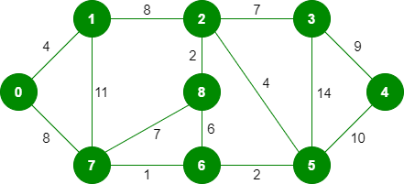

*The graph contains 9 vertices and 14 edges. So, the minimum spanning tree formed will be having (9 – 1) = 8 edges.*

*After sorting:*

*Weight Src Dest*

*1 7 6*

*2 8 2*

*2 6 5*

*4 0 1*

*4 2 5*

*6 8 6*

*7 2 3*

*7 7 8*

*8 0 7*

*8 1 2*

*9 3 4*

*10 5 4*

*11 1 7*

*14 3 5*

*Now pick all edges one by one from the sorted list of edges*

***Step 1:*** *Pick edge 7-6: No cycle is formed, include it.*

*Kruskal’s Minimum Spanning Tree Algorithm*

***Step 2:*** *Pick edge 8-2: No cycle is formed, include it.*

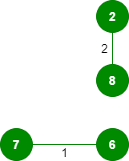

***Step 3:*** *Pick edge 6-5: No cycle is formed, include it.*

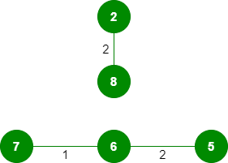

***Step 4:*** *Pick edge 0-1: No cycle is formed, include it.*

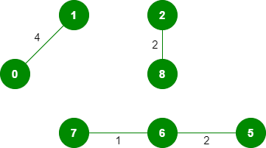

***Step 5:*** *Pick edge 2-5: No cycle is formed, include it.*

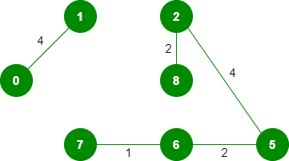

***Step 6:*** *Pick edge 8-6: Since including this edge results in the cycle, discard it.*

***Step 7:*** *Pick edge 2-3: No cycle is formed, include it.*

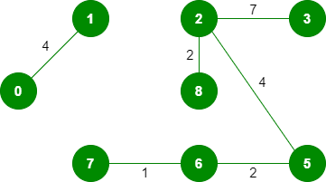

***Step 8:*** *Pick edge 7-8: Since including this edge results in the cycle, discard it.*

***Step 9:*** *Pick edge 0-7: No cycle is formed, include it.*

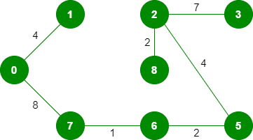

***Step 10:*** *Pick edge 1-2: Since including this edge results in the cycle, discard it.*

***Step 11:*** *Pick edge 3-4: No cycle is formed, include it.*

